**Website Report**

**Name:** Samuel Ayres

**Student Number:** S00237258

**Date :** 14/04/2023

**Proposal**

## 1. Proposed 4 Page Web Site Topic

|  |
| --- |
| I will be creating a mock website to sell a baby monitor called “Beddy-Bye”. This product is being developed in my internet of things. |

## 2. Proposed Design

|  |
| --- |
| The website will have a starry night background accompanied with images of the product. |

## 3. Proposed Design of each page content

|  |
| --- |
| The first page will introduce the product, showcasing its features and colors. Other pages will be designated for a pre-order page and about the company. |

## 4. Rough Proposed sketch of website home page -

|  |
| --- |
|  |

**Declaration of own work**

I the undersigned declare that the project material, which I now submit, is my own work. This material or project has not previously been submitted for any other assignment. Any assistance received by way of borrowing from previous work, or the work of others has been cited and acknowledged within the work. I make this declaration in the knowledge that a breach of the rules pertaining to project submission may carry serious consequences. We are aware that the project will not be accepted unless this form has been handed in along with the project.

Website Topic: A website for a mock-up company selling a product.

Student name: Samuel Ayres

Student number: S00237258

Date: 14/04/2023

**GitHub URL**

[**https://samuelayres76.github.io/S00237258-Website/**](https://samuelayres76.github.io/S00237258-Website/)

**Features Checklist**

|  |
| --- |
| **GitHub URL** *(included after checklist section)* |
| **Project Report** |
| **Minimum of 4 HTML Page Website** |
| **HTML5 standards and recommended page layout structure** |
| **Include Meta data – description, keywords, viewport - Maximize SEO** |
| **Include font family for body of page** |
| **Appropriate use of External Style Sheet – Recommended CSS** |
| **Appropriate Example using Internal Styling on HTML page** |
| **Appropriate Example using use of inline Styling** |
| **Home page content aligned to each other and visually attractive** |
| **Consistency of design on all pages above fold, aligned, use of fonts, color etc.** |
| **Appropriate use of Headings (h1, h2, h3, h4)** |
| **Appropriate use of Colors, easy to read and complimentary colors** |
| **Include an article or section with CSS that displays 2 or 3 columns** |
| **Clear, consistent and align content on page (reference all sources)** |
| **Include public domain images, with at least one image floated with text** |
| **Use of background image** |
| **Include table of data/information** |
| **Include lists of content with ordered and unordered display** |
| **Include favicon and logo on your website** |
| **Include a contact form** |
| **Verify data collected on contact form.** |
| **Include google maps and suitable video** |
| **Footer information include copyright and a footer navigation menu** |
| **Include Internal Links and External Links – Responsive webpages (70%)** |
| **Include Appropriate use of CSS Class and Id selectors** |
| **Additional Features not covered in class exercises__________________** |
| **W3C HTML & CSS Validator results (in report)** <https://validator.w3.org/nu/#file> |
| **Report include Proposal, Declaration of your own work, URL to GitHub, Rough Sketch of layout design, brief descriptions of the web site its pages and sources for information and Validator results.** |
| **Website appearance, design and Content** [**https://webdesignledger.com/10-signs-of-a-user-focused-design/**](https://webdesignledger.com/10-signs-of-a-user-focused-design/)[**https://webdesignledger.com/20-dos-and-donts-of-effective-web-design/**](https://webdesignledger.com/20-dos-and-donts-of-effective-web-design/) |

**Rough Layout Sketches**

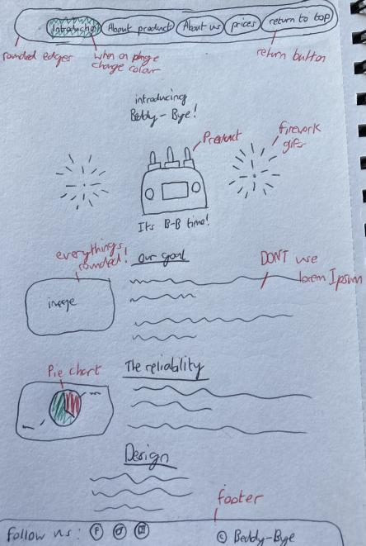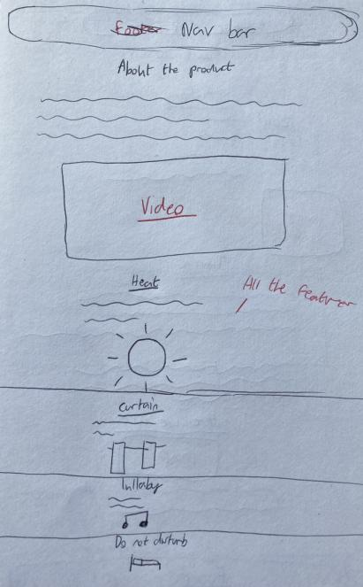

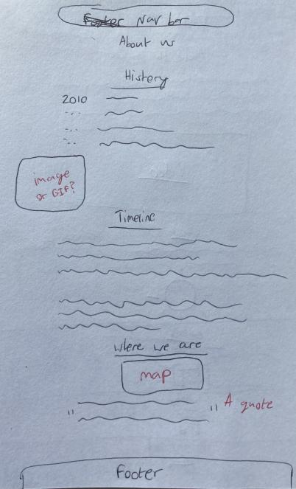 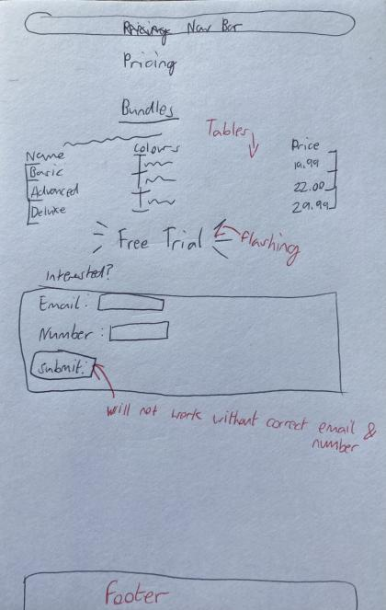

**Describing the websites features**

The Index page was always to be the introduction page. The page opens to an image of the product I created alongside two gifs of fireworks I got from https://gifer.com/en/VZvx. I wanted all images to have rounded borders to fit the soft style of the website. The sleeping baby image was sourced from <https://www.pexels.com/photo/baby-sleeping-on-white-cotton-161709/> and the pie chart was created using https://www.meta-chart.com/

Every page has the navbar follow the screen scroll. The current page will be highlighted in white. I included a “return to top” button in the navbar which returns the user to the top of the current page they are on. The footer stays at the bottom and contains links to social media websites with custom logo’s I created to stick with the colour scheme. The footer also contains the copyright for the mock up company. The favicon image was created by me. The dark blue patterned background image was sourced from https://wallpapercave.com/.

Index_2 explains what the product can do. The YouTube video was created by <https://www.youtube.com/watch?v=_q6vva2xsNc>. All images on this page were created by me once again to fit the theme. At the end of the page the user can hover their mouse over an image to flip it to see more available colours. I was inspired by the W3schools image flip concept <https://www.w3schools.com/howto/howto_css_flip_image.asp>

Index_3 is for an about us page for the mock up company “Drift”. I included a gif sourced from <https://tenor.com/view/gears-spinning-master-gis-giseros-gisero-gif-17749773> in this section. The companies (supposed) location is shown on google maps and I have two images obtained from <https://depositphotos.com/stock-photos/partners.html>.

The final page Index_4 is the pricing page. It contains a table for bundles, colours and prices. At the bottom is a second table for signing up to a free trial. The blinking/flashing text is code sourced and modified from <https://developer.mozilla.org/en-US/docs/Web/HTML/Element/blink> The code for the form was sourced and modified from <https://www.w3schools.com/html/html_forms.asp>.

**Validator Results**

The Validator came back with:

* 10 bits of Info
* 4 warnings
* 30 Errors
* Graphical user interface, text, application, email

  Description automatically generated
* Graphical user interface, text, application, email

  Description automatically generated
* Graphical user interface, application, Teams

  Description automatically generated with medium confidence
* Graphical user interface, text, application, email

  Description automatically generated
* Graphical user interface, text, application

  Description automatically generated
* Graphical user interface, text, application, Teams

  Description automatically generated